Hybrids
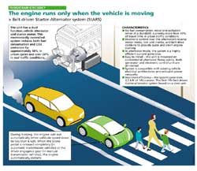 | smart fortwo to introduce automatic stop-start  The Hightech Report 2007/1 mentions an automatic stop-start system will first launch on the new smart fortwo by the end of the year. Mercedes studied a belt driven stop-start generator in cooperation with Valeo on the previous generation smart fortwo cdi. The automatic stop start is planned for the gasoline powered smart fortwo models and stops the engine when waiting at a red light to reduce emissions and to enhance efficiency. The system restarts the engine automatically once the foot is taken off the brake pedal.  smart fortwo info page  June 21, 2007
Chrysler announces new transmission plant with Getrag
The Chrysler Group will build a new transmission plant together with Getrag in Indiana. Getrag's state-of-the-art dual clutch transmissions (DCT) provide better shift quality, driving comfort, and superior fuel efficiency and replace the energy-sapping torque converters of conventional automatic transmissions with two wet or lubricated clutches - one that engages first, third and fifth gear and the other that engages second, fourth and sixth. As a result, the transmission can deliver a five to 10 percent improvement in fuel economy. If desired DCTs can be hybridized using one or two electric motors (earlier mention).
June 18, 2007
Bosch received first diesel-electric hybrid component production contract
Bosch was awarded the first production contract for a diesel-electric hybrid but would not identify the automaker. Components include the engine and hybrid controller and electric motor. Production should start by 2010. Source: Dow Jones. June 12, 2007
GM awards advanced development battery contracts for Chevrolet Volt
GM awarded two contracts for advanced lithium-ion battery development from among 13 contenders for both range-extender gasoline electric and fuel cell variants of the E-Flex architecture to speed up development of the Volt. One contract was given to Compact Power Inc. in Michigan, a subsidiary of LG Chem of Korea using their lithium-ion polymer cells with manganese spinel (LiMn2O4) based cathodes. Mercedes has been using manganese lithium-ion batteries in the B-Class F-Cell fuel cell vehicle introduced in 2005 (earlier mention). The other contract was awarded to Continental Automotive Systems, who recently announced plans for lithium-ion batteries and who have been working with GM on hybrids since 2003. Continental will integrate A123Systems nano coated lithium iron phosphate (LiFePO4) cells.
June 5, 2007
Mercedes to build Citaro G series hybrid bus prototype
Mercedes works on a diesel electric hybrid drive for the Citaro G articulated bus, announced at the UITP congress in Helsinki. Four electric motors with 320 kW overall are integrated into the rear and center wheel hubs, probably similar to the wheel hub motors used in the HyFLEET:CUTE fuel cell bus program. The bus allows driving in electric only mode and should improve the fuel efficiency 20 to 30% compared to conventional diesels. A lithium-ion battery system on the roof in a series hybrid configuration is powered by a 4.8 liter genset diesel, downsized from the 12 liter inline 6 used for conventional Citaro Gs. The lighter engine and absence of an automatic transmission reduce the hybrid's weight penalty to just about one ton. Prototypes are to be introduced later this year, pilot tests are planned for 2008 and series production is scheduled to start in 2009. But it costs about a third more compared to conventional diesels and may thus not be cost effective unless subsidized or incentivized.
May 21, 2007
BMW steers away from hybrid powertrains - report
BMW revealed to journalists in Britain hybrids will not be part of their range for the forseeable future, although BMW codeveloped the two mode hybrid. Instead BMW will focus on "Efficient Dynamics", a package of technologies and energy management systems including automatic stop-start and regenerative braking, which will be spread through BMW's model range as it's renewed.
May 9, 2007
BAE Systems Hybridrive to use A123Systems Lithium-Ion batteries
BAE Systems will integrate A123Systems phosphate lithium ion batteries into the next generation Hybridrive series hybrid starting in 2008. The diesel-electric Hybridrive power Orion VII bus fleets at the Toronto Transit Commission, the San Francisco Municipal Railway (MUNI), and the Port Authority of New York and New Jersey (earlier mention). NREL and Battelle studied the fleet performance in New York and found an average improvement in the fuel economy of 34% compared to a standard diesel drive. Lithium-ion batteries will further enhance the efficiency.
New York City Transit Hybrid and CNG Buses: Final Evaluation Results
May 8, 2007
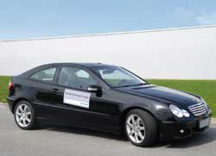 | Siemens VDO update on Fuel Efficiency  Siemens VDO released an update on their fuel efficiency work recently. In addition to advanced combustion research to optimise gasoline and diesel fuel injection they continue to pursue the electrification of the powertrain. Siemens supplied the electric motors for the world's first series produced diesel hybrid, the Audi Duo A4 Avant in 1997 (earlier mention). In a mild hybrid they elevate the fuel efficiency by 15% and in a full hybrid by 25% in the NEDC test cycle. Furthermore several small steps like anticipatory driving with their "Power Trader" onboard vehicle energy flow monitor combined with optimal shift points can reduce the consumption by 25% as well.  April 29, 2007

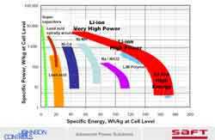 | Saft adds new lithium ion technology to its product portfolio  Saft launches LiFePO4 for defence applications. Lithium iron phosphate technology was licensed from the University of Texas. While the performance is lower than their standard LiNiCoAlO2 lithium ion cells, it has higher thermal stability. LiNiCoAlO2 cells can become thermally instable if not well controlled. According to Saft there are still some challenges ahead to make LiFePO4 compatible with automotive applications.  April 25, 2007
Bosch receives first major gasoline-electric hybrid contract: Touareg, Cayenne, Q7
During the wide ranging annual press conference Franz Fehrenbach announced Bosch had received a first major contract for a gasoline-electric hybrid, with an expected fuel efficiency improvement of 25% in urban traffic compared to conventional port injection systems. According to several press reports it's for the VW Touareg, Porsche Cayenne and Audi Q7. Series production should start late 2008 with an anticipated annual volume of 30,000 to 40,000, and up to 100,000 units lateron.
April 25, 2007
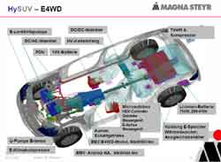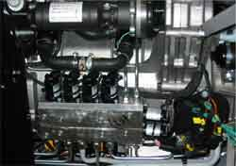 | Magna Steyr shows HySUV electric 4 wheel drive (e4WD)  Magna Powertrain and Siemens VDO developed the ML350 HySUV gasoline-electric 4WD prototype. Two electric motors rated at 55 kW peak each are integrated into the electric four wheel drive (e4WD) module mounted between the 3.5 liter V6 gasoline engine and the transmission. It's a parallel hybrid with a second electric motor driving the front axle, employing 4 clutches thus enabling 21 individual operating modes. Supported functions include edriving, automatic stop-start, brake energy regeneration and power boost to raise the acceleration torque and times to ML500 level. But instead of guzzling gas like a ML500, the HySUV is as fuel efficient as a ML320 CDI diesel. The e4WD full hybrid system adds quite a bit of complexity, cost and a weight penalty of 250 kg in the prototype. Development work is ongoing to reduce the additional weight to 160 to 180 kg.  8th European AWD Congress Graz: HySUV e4WD paper  Auto Motor und Sport: Magna Steyr ML350 HySUV  April 23, 2007

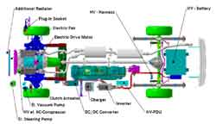  DaimlerChrysler PHEV Prototype  and Field Test Evaluation Program  Sprinter page | New York Times to operate Sprinter Plug-in Hybrid  The New York Times is first to run a plug-in hybrid on the East Coast, was revealed today. The Sprinter will be used as distribution vehicle at their printing plant in College Point, Queens and transport New York Times newspapers to The Times's headquarters in midtown Manhattan, as well as to different locations in the New York City area. Partners are DaimlerChrysler, the New York Port Authority, the Electric Power Research Institute and Con Edison. "We are proud that The New York Times is the first major entity in the State of New York with a plug-in hybrid electric vehicle in our fleet," said Tom Lombardo, vice president, production, The New York Times. "When we were approached by NYPA and DaimlerChrysler, we knew immediately that we wanted to be involved. We are delighted to be supporting the use of clean energy, sustainability and advances in plug-in hybrid technology."  April 11, 2007
PG&E Energizes Silicon Valley With Vehicle-to-Grid Technology
Pacifc Gas and Electric showed a prototype plug-in hybrid which was converted in partnership with the Bay Area Air Quality Management District and Energy CS, which added a lithium ion battery to a traditional Toyota Prius. The additional battery capacity increases the vehicle's ability to run completely on electricity. In front of many of the Silicon Valley's industry and governmental leaders, PG&E showed the reverse flow of energy from the vehicle back to the outlet -- a first public showcase for any utility. Once connected to the outlet, PG&E then ran several lights and appliances to show how V2G could benefit its customers. "PG&E's V2G demonstration marks an important milestone for plug-in vehicle technology," said Felix Kramer, Founder of CalCars.org. "Using a grid-connected car's battery as distributed energy storage for homes or businesses expands the economic and environmental benefits of plug-in vehicles."
Pacific Gas & Electric Company
April 9, 2007
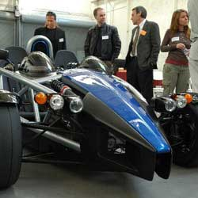 | Wrightspeed's X1 Electric Supercar Sparks Hybrid Dreams  Wrightspeed rolled out the X1 recently to spark interest in a future plug-in hybrid design they are working on. When it was shown last year, the pure electric X1 prototype blew away Ferraris in drag races. The X1 is powered with lithium ion batteries and 3 phase AC induction motor and inverter supplied by AC Propulsion.  Wrightspeed - Cleantech Supercars  Apr 6, 2007
Santa Barbara MTD rolls out Hybrid Bus Fleet
The Santa Barbara metropolitain transit district unveiled their new hybrid bus fleet. The parallel hybrid is based on the Cummins inline six and Allison two mode transmission, and built by the Gillig Corporation. Starting this summer they can use B20 biodiesel since Cummins recently approved it. The drivetrain architecture is similar to the Solaris Bus & Coach in the Dresden trial.
The Gillig Hybrid
Santa Barbara MTD
Apr 4, 2007
DaimlerChrysler Expands Concept Plug-in Hybrid Program to New Sprinter
DaimlerChrysler is expanding their Sprinter plug-in hybrid test program to include the all new 2007 Dodge Sprinter. Up to 20 Dodge Sprinter Plug-in hybrid vehicles will be placed into the test fleet program in the United States between now and 2008. 4 of the previous generation Sprinters are already in the test program. Battery technology comprises one part of the testing. Lithium-ion holds the greatest promise and a number of the Sprinters are equipped with it, with about half the weight and much greater storage capacity when compared to nickel-metal hydride batteries. The test program will yield technical information through real world driving conditions, about lifetime, performance and cost of the batteries. The Sprinter PHEV can drive up to 20 miles on electric-only power. This is accomplished with a switch on the dashboard to manually select operating modes, or automatically by the vehicle control system. Gasoline or diesel powerplants are offered. The diesel yields the highest fuel efficiency. Plug-in hybrids are suitable for delivery vans with short stop and go routes, where they can consume very little fuel. The Sprinter PHEV was developed with the Electric Power Research Institute (EPRI) in Palo Alto, California.
Plug-In Hybrid Electric Vehicles Technology Challenges
Environmental Benefits of PHEVs
Mar 27, 2007
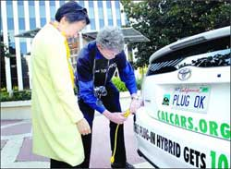 | Palo Alto Daily News: Mayor kick off Plug-in Hybrid Drive  CalCars Felix Kramer kicked off the plug-in-hybrid vehicle drive with Palo Alto Mayor Yoriko Kishimoto today. The vehicles can be plugged into the grid overnight to recharge them and can drive up to 100 miles per gallon. The campaign was started to show interest in plug in hybrid technology and to entice major manufacturers to offer them in the future. The national Plug-in campaign has already gathered more than 7,000 orders for plug-in vehicles.  Mar 23, 2007

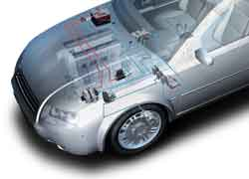 | Mercedes is working on Automatic Stop-Start  Bosch supplies Smart Electronic Stop-Start (SES) for the BMW 1-series where it became standard on 4 cylinder models with manual transmission. Thus, when coming to a stop in traffic the engine shuts off automatically once the clutch pedal is released, and starts up again, once the pedal is depressed to engage the gear. Mercedes developed it previously for the first generation smart fortwo cdi using a belt driven starter generator, where the engine restarts once the brake pedal is released.  Mar 13, 2007

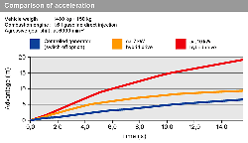 | Standard Brake Energy Regeneration Debuts  BMW brake energy regeneration via intelligent alternator control became standard on the new BMW 1-series and new BMW 5-series. The intelligent alternator mainly charges the battery during braking and overrun conditions, and disconnects when accelerating, enhancing power and agility. Continental compares the acceleration (blue curve).  Mar 13, 2007

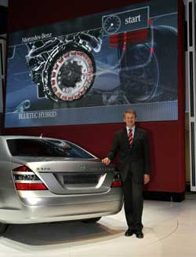 | Mercedes might introduce two hybrid systems in 2009  Mercedes chief of research and development said at the Geneva auto show that Mercedes may introduce two different hybrid concepts in 2009. And a Bluetec hybrid might also be worth to consider.  Last summer he told Wirtschaftswoche to expect a S-Class hybrid early 2008.  Mar 10, 2007  BMW DaimlerChrysler to Cooperate on Efficient Dynamics  BMW and DaimlerChrysler are expanding their collaboration in the field of hybrid drive systems and will participate as equal partners in the development of an innovative hybrid module for rear-wheel-drive premium segment cars. They both plan to offer it within three years, first for gasoline engines due to the greater potential fuel savings, but diesels are not excluded. Development will take place in Germany at the respective powertrain development facilities.  Mar 1, 2007

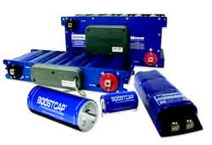 | BMW's Burkhard Goeschel Joins Maxwell's Board  Professor Burkhard Goeschel, who retired in November 2006 from BMW, with overall responsibility for research, development and purchasing, has been appointed to ultracap manufacturer Maxwell's board of directors. The Concept X3 Efficient Dynamics used ultracaps integrated into the door sills, suggesting they might be planned for series production in the future. Ultracaps can be as effective as Li-Ion batteries, in hybrids with high power but lower energy requirements.  February 27, 2007
Sьdchemie to invest in lithium iron phosphate production
Sьdchemie invests in Quebec lithium iron phosphate production for use in a new generation of lithium-ion batteries, which wont blow up as easily as the more conventional LiNiCoAlO2 based lithium ion cells known from laptops. Phostech Lithium in Boucherville/Canada, an affiliate of Sьd-Chemie AG, Munich, has completed the construction of a production line of 300 metric tons per year of lithium iron phosphate (LiFePO4). Phostech Lithium cooperates with Bosch Power Tools to develop lithium-ion batteries with iron phosphate cathodes, with an expected market launch in 2007.
February 10, 2007
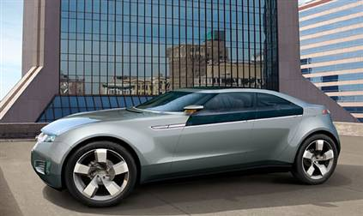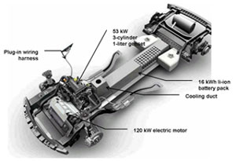
GM revives the electric car: Sleek Chevy Volt concept unveiled
The Volt has a 40 mile range on 16 kWh lithium ion batteries alone, and can be recharged either by plugging into a standard 15A outlet, or using the onboard 1 liter 3 cylinder turbocharged engine with generator set (genset) rated at 53 kW in a series hybrid config, which extends the range to 640 miles on 12 gallons of fuel. The Volt has some similarities with the Swatchmobile proposed by Nicolas Hayek in 1994. GM plans to produce them once suitable batteries become available in a few years. Since it's based on the E-Flex architecture the Volt can also be adapted to hydrogen fuel cell or all electrical power, says Nick Zielinski, chief engineer for the Volt.
Jan 7, 2007
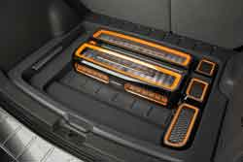 | Johnson Controls-Saft and Cobasys A123Systems to design and test GM plug-in hybrid battery  To be based on lithium-ion technology and intended for the Saturn VUE Green Line two mode plug-in hybrid SUV expected in 2008. The picture shows JCS' hybrid electric vehicle lithium ion battery pack in a SUV.  Jan 4, 2007

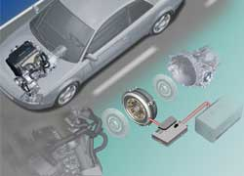 | Siemens VDO to acquire Ballard's Electric Drive Business  Siemens VDO Automotive plans to purchase Ballard Power System's Electric Drive Business located in Dearborn, Michigan, to round out their hybrid drive and fuel cell drive system offerings. The picture shows Siemens VDO's full hybrid system. Siemens hybrid drives are available from ISE Corporation.  Dec 21, 2006
Toyota aims to commercialize diesel hybrid car in 2010
Japan Today reported Toyota plans to introduce a diesel-electric subcompact in cooperation with Isuzu Motors by 2010. Nov 28, 2006
Degussa, Volkswagen set up Lithium-Ion professorship
Degussa announced a new institute for Applied Materials Sciences for Energy Storage and Conversion at Mьnster University, in cooperation with Chemetall and Volkswagen. The intention is to focus on large format lithium-ion battery technology for hybrids. Degussa writes: "The task in this respect is to improve the energy and power density of batteries and their safety and durability, all important prerequisites for significantly lowering the costs of battery systems." Degussa makes the SEPARION® flexible ceramic foils and also electrodes for lithium ion batteries.
Degussa SEPARION®
Oct 16, 2006
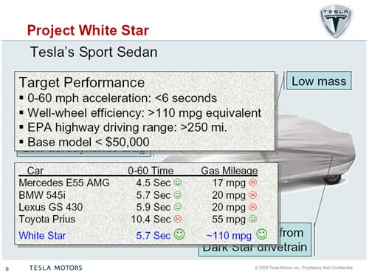 | Project White Star update  Tesla presentation (pdf)  9/30/2006
FedEx puts 75 more hybrid delivery trucks into service
FedEx together with Eaton and Freightliner developped hybrid delivery trucks and had been running 18 prototypes. More recently a further 75 vans were built to go into service in New York City and other cities by this summer. The Stanford Graduate School of Business case study gives some background of the development process. The W700 Step Vans use a 4.3 liter Mercedes OM904 inline 4 diesel engine from the well established European 900 series known as the MBE 900 in the USA and with an output of 125 kW (167 hp), Eaton developed direct hybrid transmission, Li-Ion batteries and are assembled by Freightliner Custom Chassis in Gaffney South Carolina. FedEx was awarded the 2005 Blue Sky Award by CALSTART for "its nearly single-handed placement of commercial hybrid trucks on the map for corporate America. The FedEx and Environmental Defense effort led the commercial truck market’s interest and efforts into the hybrid market."
Stanford case study: FedEx and Environmental Defense: Building a Hybrid Delivery Fleet (pdf)
Heavy Hybrid Vehicle Commercialization Progress and Directions The HTUF Process, CalStart/WestStart (pdf)
9/16/2006
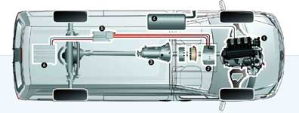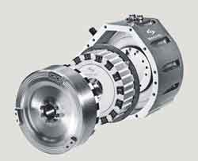
Sprinter hybrid electric and plug-in hybrid electric drive
Inner-city delivery vans do most of their work in areas where emissions are a major issue, therefore DaimlerChrysler is intensively developing alternative drive systems. Top right: ZF Sachs produces the strong Sprinter electric motor with 70 kW placed between combustion engine and transmission.
Sprinter info page
9/15/2006
Johnson Controls-Saft awarded program for lithium-ion batteries
A major automaker signed a letter of intent with Johnson Controls Saft Advanced Power Solutions (JCS) joint venture to produce a Li-Ion battery for a hybrid electric vehicle for evaluation, with production anticipated in the future. This would be the first JCS Lithium Ion hybrid battery plant in Europe, costing $15 to $20 million and be located in the eastern part of France.
JCS Li-ion High voltage battery for automotive application (pdf)
JCS plug-in hybrid and full hybrid Li-ion specs
9/6/2006
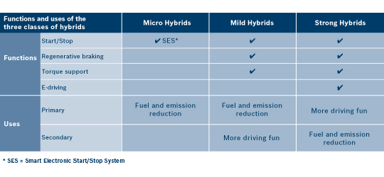
Bosch video: Micro Hybrid Start Stop System (SES), Mild & Strong Hybrid
Bosch is getting up to speed. They updated their webserver to include hybrid info, explaining the difference between micro hybrid, mild and strong hybrid, including videos, and also established the Bosch Hybrid System Project House in 2004.
9/5/2006
NO MBUSA two-mode hybrid plans
Paul Halata, MBUSA's parting CEO, says MBUSA plans no two mode hybrid within a year after the Chrysler Group's and General Motors hybrid SUVs debut. DaimlerChrysler jointly developed the P1/2 transmission with GM and BMW. MBUSA plans to focus on turbodiesel SUVs instead.
diesel page
8/17/2006
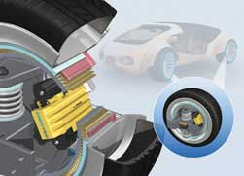 | Car motor disappears into the wheels: Siemens VDO eCorner  Siemens engineers are starting to develop their new eCorner concept. The electric motor, brakes, suspension and steering are integrated into the wheel hubs at each corner of the vehicle. The Electronic Wedge Brake (EWB) is part of the eCorner concept and might be first to start series production, around 2010. Previously Richard Schaum at WaveCrest developed a somewhat similar concept, with electric wheel hub motors in a smart coupe. Even earlier the Lohner Porsche Mixte in 1902 featured such a concept.  Siemens VDO press release  Aug 8, 2006
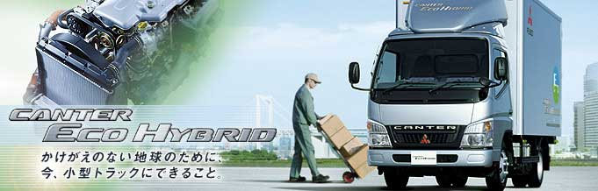
click on pic for schematic
Canter Eco Hybrid goes into production
It's powered by a 3.0 liter four cylinder turbodiesel with 125 hp (92 kW) and a slim 35 kW (48 hp) electric brushless motor in a parallel hybrid configuration, with Li-Ion batteries (346 Volts, 5.5 Ah, 1.9 kWh, 96 cells), and is now shipping in Japan. The Eco Hybrid can be driven by either the diesel engine or the electric motor, or both in parallel and using Mitubishi Fuso's Inomat automated manual transmission. The integrated regenerative braking system produces an additional fuel savings of as much as 20%. Last March Mitsubishi Fuso showed a prototype at the MidAmerica Trucking Show to evaluate interest. Owing to extremely densely populated areas, hybrid vehicles such as the Canter ECO Hybrid play an important role in Japan.
What Van? review of Canter ECO Hybrid
7/6/2006
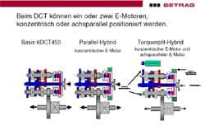 | Bosch and Getrag form hybrid alliance  They plan to integrate dual clutch transmissions and electric drives to provide turnkey solutions to automakers. The picture shows the parallel and torque-split hybrid configurations on the basis of the Getrag 6DCT450 six speed dual clutch transmission for 450 Nm input torque. The parallel hybrid configuration uses one concentric electric motor, while the torque-split hybrid has two.  Bosch press release  Getrag press release  6/8/2006
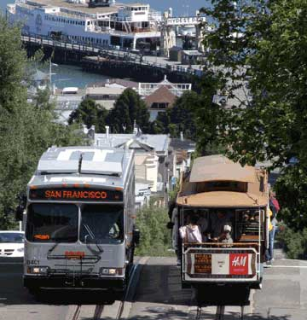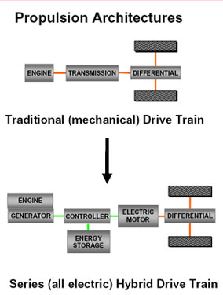
California's first diesel electric bus goes into service today
56 Clean Air DaimlerChrysler Orion VII low floor buses are to roll out in the fall. San Francisco Muni will own the third largest hybrid fleet in the United States. The buses use the BAE Systems diesel-electric series hybrid HybriDrive based on a 5.9 liter Cummins ULSD turbodiesel and electric traction motor with 250 hp and 320 hp peak. Last fall New York City Transit / MTA Bus ordered a large fleet, Transit Toronto already operates them and in St. Louis the Missouri Metro is testing them.
www.dcbusna.com
SF Muni
6/1/2006
GM, DaimlerChrysler, BMW release some details
about the new two mode hybrids. The electric continously variable transmission (ECVT) has two electric modes and four fixed mechanical ratios. In summary, the four fixed gears overlay two ECVT modes for a total of six operating functions:
- Input-split ECVT mode, or continuously variable Mode 1, operates from vehicle launch through the second fixed gear ratio.
- Compound-split ECVT mode, or continuously variable Mode 2, operates after the second fixed gear ratio.
- First fixed-gear ratio with both electric motors available to boost the internal combustion engine or capture and store energy from regenerative braking, deceleration and coasting.
- Second fixed-gear ratio with one electric motor available for boost/braking,
- Third fixed-gear ratio with two electric motors available for boost/braking.
- Fourth fixed-gear ratio with one electric motor available for boost/braking.
The result, say the three collaborators, is ”trend-setting hybrid technology that provides superior fuel economy, performance and load carrying capability”.
Key Advantages.
When compared to conventional hybrid systems, this avant-garde hybrid technology, relying on both the ECVT modes and the four fixed gear ratios, provides advantages in combined (city and highway) fuel economy, dynamics and towing capability.
Traditional hybrid systems typically have only one torque-splitting arrangement and no fixed mechanical ratios. These systems are often called "one-mode" hybrids. Due to their less capable mechanical content, one-mode hybrids need to transmit a significant amount of power through an electrical path that is 20 percent less efficient than a mechanical path. This requires usually substantial compromise in vehicle capability or reliance on larger electrical motors, which can create cost, weight and packaging issues.
General Motors, DaimlerChrysler and the BMW Group conceive a full hybrid system featuring four fixed mechanical ratios, within the two ECVT modes, to reduce power transmission through the less efficient electrical path. Consequently, the electric motors are more compact and less dependent on engine size.
This combination of two ECVT modes and four fixed gear ratios eliminates the drawbacks of one-mode hybrid systems to allow for efficient operation throughout a vehicle's operating range, at low and high speeds. It also allows for application across a broader variety of vehicles. It is particularly beneficial in demanding applications that require larger engines, such as towing, hill climbing or carrying heavy loads.
Existing internal combustion engines can be used with relatively minimal alteration because the full hybrid system imposes no significant limitation on the size or type of engine. It enables the three automakers to package internal combustion engines with the full hybrid transmissions more cost-effectively and offer the fuel-saving technology across a wider range of vehicles.
4/30/2006

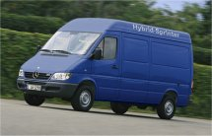 | EPRI Journal: "The Plug-In Hybrid Vehicle"  DaimlerChrysler in Mannheim built the Sprinter Plug-In Hybrid Drive vehicles for the test program. "The PHEV is unique. It offers the optimal mix of power from the battery and the engine - of energy from the grid and the gas station to consumers of various transportation needs", says Dr. Fritz Kalhammer, EPRI. Utilitarian Sprinters are often used within the 20 to 30 mile short haul range which may be suitable for PHEV technology.  Read the EPRI article here  Plug-In Hybrid Electric Sprinter Prototype (in pdf)  PHEV Energy Storage System Design (May 2006)  Plug-In Hybrid Development Consortium  Sprinter info page  3/12/2006

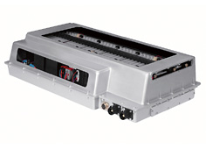 | NiMH full hybrid battery  Johnson Controls Saft subsidiary Varta has been working on hybrid batteries for the last decade. This is their 270 Volt 1.9 kWh nickel metal hydride battery for full hybrids. It uses forty 7.2 Volt 7.0 Ah modules and includes an energy management controller. For the Sprinter PHEV they supply NiMH or Li-Ion batteries. The Sprinter PHEV NiMH battery comprises 7 times 40 modules with 40 Ah, 14.4 kWh and weighs 364 kg. In electric mode the Sprinter has a range of about 2 miles per kWh.  3/10/2006

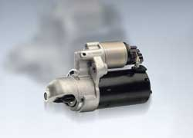 | Smart Electronic Start/Stop System (SES) for micro hybrids  Bosch starts production of a micro hybrid with SES later this year. The engine stops when standing and starts again with a reversible alternator. Micro hybrids are cost effective, easier to integrate and reduce fuel consumption up to 8%.  Feb 14, 2006
PSA Peugeot Citroлn unveiled diesel-electric hybrid prototype
PSA Peugeot Citroлn unveiled two demonstrators featuring a diesel-electric hybrid powertrain, the Peugeot 307 and the Citroлn C4 Hybride HDi. The performance of these cars represents a major breakthrough in further improving fuel economy and reducing CO2 emissions. They also provide increased driving comfort under all conditions, especially in urban traffic. The main features of the Peugeot 307 prototype are:
- 1.6 liter 66 kW HDi turbodiesel with EU 4 particulate filter
- parallel hybrid drive configuration
- synchronous permanent magnet electric motor rated at 16 kW continuous and up to 23 kW peak
- new generation stop/start system
- six speed automated manual gearbox
- fuel consumption of 3.4 liters per 100 kilometers (NEDC, combined) - 90 g CO2 per kilometer - 69 MPG
- 240 NiMH battery cells with 288 Volt total
- all electric driving with up to 50 km/h
PSA Peugeot Citroлn diesel-electric hybrid
January 31, 2006
VW starts hybrid cooperation with Continental, ZF, SANYO
Volkwagen ordered a hybrid power control module from Continental Automotive Systems. The EP220 hybrid controller takes 100 kVA CW and 160 kVA peak for up to 60 seconds. Continental also received a specific order for the hybrid drive modules. ZF will supply the electric motor, the clutch and the dual-mass flywheel. SANYO and Volkswagen agreed to codevelop next generation Nickel Metal Hydride HEV battery systems.
January 31, 2006
The BMW Concept X3 EfficientDynamics
Rainer Rump the General Manager Hybrid Cooperation BMW talks us through the innovations that make up the BMW Concept X3 EfficientDynamics.
Vodcast
January 17, 2006
Degussa expands production for lithium-ion electrodes
Degussa expands electrode production for large format lithium-ion batteries at Li-Tech GmbH (SK Firmengruppe) in Kamenz near Dresden. They already cooperate with ENAX at a facility in China.
Jan 13, 2006
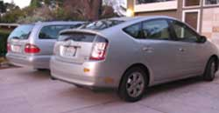
"The California HybridMercedes" = Mercedes + Prius
With the sticker single occupant Prius can use car pool lanes. The Prius can't be plugged into the grid like the Sprinter PHEV. Folks are working on an upgrade kit. And it's not a diesel.
CalCar's PHEV
Hybrid sales reach 200,000 in 2005
Hybrid vehicle sales increased to more than 200,000 in 2005 up from 9500 in 2000. In comparison 543,000 diesel vehicles were sold last year in the USA, including E320 CDI, Jeep Liberty, Sprinter van and Dodge RAM.
Dec 15, 2005
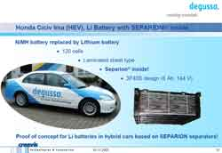 | Degussa tests Honda Civic IMA hybrid with SEPARION  The battery of a Honda IMA hybrid was updated to Lithium Ion, using the SEPARION ceramic foil supplied by Degussa. SANYO Electric supplies Honda hybrid batteries.  Degussa SEPARION®  Nov 10, 2005

 | F600 Hygenius introduced in Tokyo  An amazingly advanced fuel cell research F600 was introduced at the Tokyo 2005 auto show with 115 hp (85 kW) and 350 Nm running on fuel cell and Li-Ion battery in hybrid mode. With the new compact fuel cell alone it achieves 82 hp (60 kW) and 250 Nm. It has a 250 mi range and the new high efficiency electric motor is integrated into the rear axle. Mercedes optimistically predicts commercial fuel cell vehicles running on hydrogen for 2012 to 2015. And the son reads Papa Moll. Hybrids are a step towards a future hydrogen highway.  Oct 12, 2005
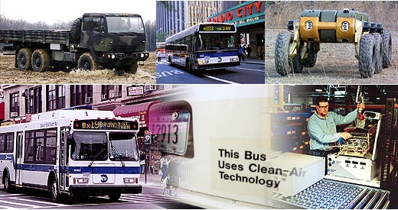
NYC orders 500 Orion VII diesel electric hybrid buses
After testing diesel electric hybrid buses for several years, New York City Transit, MTA Bus placed a large order with DaimlerChrysler for 500 Orion VII low floor buses equipped with the diesel electric HybriDrive using the 5.9 liter inline 6 Cummins turbodiesel, in a series hybrid configuration, like the Mercedes diesel electric test bus shown in 1969.
BAE HybriDrive
Oct 11, 2005
JESMB Testdrives CLK 500 ISG M273
JESMB drove a CLK 500 ISG Hybrid prototype at the IAA. It has the new M273 E 55 (5.5 liter V8 with 388 hp und 530 NM) V8 and the ISG integrated starter generator hybrid. There is no engine running at the red light but surprisingly the climate system keeps running. It takes only 0.3 seconds to start. Overall the fuel economy is estimated to be around 9-10 liter per 100 km with the ISG saving around 6%.
JESMB
Sep 13, 2005
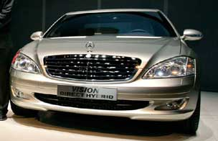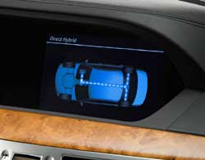
"DIRECT HYBRID" and "BLUETEC HYBRID" S-Class concept cars
Mercedes showed two concept cars at the IAA 2005 in Frankfurt. The DIRECT HYBRID uses spray-guided direct gasoline injection and an 6 kW/8.2 hp electric motor and a DeNOx catalyst. Fuel consumption drops due to a combination of spray-guided injection and the start/stop mild hybrid. The BLUETEC HYBRID uses a 3.0 liter V6 turbodiesel, the same electric motor and SCR to clean the exhaust. The diesel engine can be run more efficiently with SCR/Adblue reducing consumption in addition to the start/stop system. This mild hybrid captures benefits like start/stop, regenerative braking and torque assist at low engine speeds with comparable low cost.
S350 DIRECT HYBRID 221 kW/300 hp 395 Nm 7.5 sec 0-100 consumption in l/100km: 8.3 instead of 10.2
S320 BLUETEC HYBRID 179 kW/243 hp 575 Nm 7.2 sec 0-100 consumption in l/100km: 7.7 instead of 8.4
Sep 13, 2005
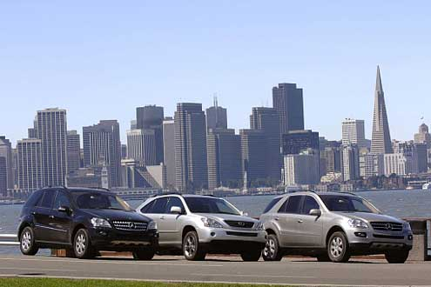
DIESEL BEATS HYBRID: ML320CDI RX400h Coast-to-Coast-Marathon
Autobild tested diesel vs hybrids in a coast to coast marathon. Overall results:
ML320CDI driven 5229 kilometers
RX400h driven 5126 kilometers
ML320CDI 127.4 gallons fuel
RX400h 139.3 gallons fuel
ML320CDI consumption 9.2 liters/100km (25.5 MPG)
RX400h consumption 10.3 liters/100km (22.9 MPG)
diesel info page
8/7/2005
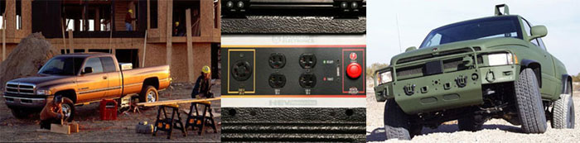Dodge RAM Contractor Special
The RAM diesel HEV comes with a 5.9 liter Cummins turbodiesel with 325 hp / 600 lb-ft, starter/generator, 20-30 kW off-grid power generation capability with 110/220 AC outlets, regenerative braking and better fuel economy. Small scale production started in December 2004 and it's only available to fleet customers.
GMC Tahoe Two-Mode hybrid
This full hybrid employs two electric motors, one for stop and go driving and another one (mode 2) runs at highway speed, improving both city and highway fuel economy by about 25%. The technology is developed with DaimlerChrysler and should come to market in 2007.
2008 GMC Tahoe (estimated)
EPA CITY: 20 MPG instead of 16
HIGHWAY: 25 MPG instead of 20
4/11/2005
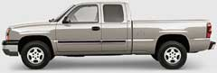
GMC Sierra and Chevrolet Silverado RWD hybrid
In this mild hybrid the Continental supplied integrated starter, generator and damper (ISAD) installs between the engine and transmission, thus reducing gas consumption up to 15%, depending on driving cycle. First installed in the 2004 GMC Sierra. The ISAD system was first developed to ease the transition to 42 Volt electrical systems. The later did not become popular, however. Update: Overall 3000 were produced before production ended in December 2006 as the technology was not brought forward to the new platform.
EPA CITY: 18 MPG instead of 16
HIGHWAY: 20 MPG instead of 19
3/1/2005
Ford Escape Hybrid 4WD SUV
Comparing the standard version with 4 cylinder, 4WD and automatic with the hybrid, the fuel economy improves quite a bit in the city and less so on the highway. Conti Teves supplies the regenerative brake (and ESP) system.
EPA CITY: 33 MPG instead of 19
HIGHWAY: 29 MPG instead of 22
2/1/2005
E-class diesel with good highway fuel economy
MBUSA offers the E-class with gas or diesel. The E320 CDI improves the highway and also the city fuel economy of the E320 by more than 30% each while also accelerating faster. Better economy than a hybrid and it's built in Sindelfingen.
EPA CITY: 27 MPG instead of 20
HIGHWAY: 37 MPG instead of 28
Lexus RX400h introduced
It improves the 0-60 by half a second to 7.3 seconds while also increasing the combined fuel ecomony by 33% to 28 MPG (30 MPG CITY, 26 MPG HWY) compared to the RX330 AWD. It's quite complex with three separate electric motors: the NG1 starter generator, the NG2 123 kW motor with permanent magnets and the NGR 50 kW rear axle motor in addition to the 3.3 liter gasoline V6 with 208 hp. Overall it's rated at 268 hp and can add up to 247 lb-ft. at launch on the front axle and 96 lb-ft. on the rear axle. But most owners claim the published numbers are too optimistic obtaining only up to 25 MPG, even in city driving!
EPA CITY: 31 MPG instead of 18
HIGHWAY: 27 MPG instead of 24
2/1/2005
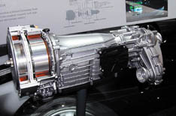
Active M-class transmission
This 7G-Tronic seven speed transmission was shuffed into a corner at the North American International Auto Show 2005 and was not mentioned officially for unknown reasons. It integrates two electric motors with 25 kW (34 hp) each and 147 lb-ft and 221 lb-ft of torque instead of the torque converter and can thus add up to 368 lb-ft or 500 Nm of torque. It's also mated to a four wheel drive transfer case. BMW researches a similar setup.
X5 research car
1/23/2005

S400 diesel-electric hybrid concept with 328 hp (241 kW) introduced
Mercedes showed the S400 diesel-electric Hybrid at the 2005 North American International Auto Show improving both dynamics and efficiency. The P1/2 hybrid transmission replaces the torque converter in the 7G-tronic, combining an efficient 260 hp (191 kW) V8 CDI diesel with two electric motors with a combined 50 kW (68 hp) and a nickel metal hydride battery with a capacity of 1.9 kWh in the trunk. The S400 Hybrid is faster to 100 with 7.6 seconds instead of 7.8 and the fuel economy improves to 34 mpg US (around 7 l/100km), about 15 to 25% better than a standard S400 CDI with 9.6 l/100km. Mercedes engineers promise silky smooth nearly continuous shifting.
1/9/2005
DaimlerChrysler and GM Join Forces to Develop Two-Mode Full Hybrid Propulsion System
The result is expected to be a series of strong hybrid propulsion systems that will serve as a solution for our alternative powertrain needs." MB will focus on high-tech hybrid propulsion systems in passenger cars in the luxury segment. Volkswagen may also be interested in this technology. The first products will be the Dodge Durango and GMC Yukon in 2007 and furtheron this technology will be used in GM, Chrysler and Mercedes vehicles.
Allison Electric Drives (pdf)
12/13/2004
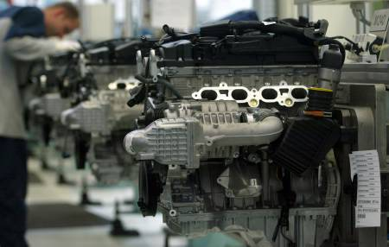
Mercedes to develop gasoline electric hybrid
Mercedes-Benz will bring to market a gasoline electric hybrid with rear wheel drive, designed particularly with the market in Japan and the USA in mind, in areas with much stop-and-go traffic. "It will take less than 5 years and will be a typical Mercedes-Benz premium vehicle", said chief of development Thomas Weber. To save costs, Mercedes is completely open to cooperate with suitable partners and suppliers. Reuters
10/25/2004
SANYO may develop Mercedes-Benz hybrid batteries
SANYO Electric Co., Ltd. may develop batteries for Mercedes hybrid electric vehicles. They also make battery systems for DaimlerChrysler's fuel cell program and have similar battery contracts with Ford and Honda.
10/19/2004
Update on F500 Mind diesel-electric hybrid research car
Hybrid drive returns fuel savings of as much as 20 percent in NEDC cycle - but not real world
Practical research revealed both the benefits and drawbacks of the alternative drive technology. One of the plus points is the electronic load share apportionment between engine and electric motor: when driving in slow-moving stop-go traffic, pulling away or parking, the diesel engine is shut off and the F 500 Mind switches to purely electric drive. This allows fuel consumption to be cut by some 20 percent in the NEDC cycle. Just the ability to switch off the diesel engine when stopped at traffic lights and pull away again using the power from the electric motor represents a fuel saving of around ten percent. Automatic energy recovery during braking also comes into the equation, accounting for a further five to seven percent reduction. However, researchers at DaimlerChrysler detected a discrepancy between theory and practice, as the fuel consumption figures for the NEDC test cycle and for testing under practical operating conditions did not tally. "The actual fuel consumption of the hybrid drive on longer interurban or motorway journeys is actually higher than with the standard Mercedes diesel model," says Dr Herbert Kohler, Powertrain Research and Chief Environmental Officer for DaimlerChrysler, and continues: "We are looking to fine tune the hybrid drive and deploy it in such a way that its benefits outweigh the tremendous technical effort involved. As a result of the practical tests that have been held so far, we now know that the diesel engine holds a greater overall potential for reducing fuel consumption and levels of CO2 emissions."
diesel engines
10/8/2004
Sprinter Hybrid and Sprinter Plug-in Hybrid Drive
is a gasoline-electric or diesel-electric hybrid drive, developed with the EPRI and ZF-Sachs, and introduced at the IAA commercial vehicles in September 2004 in Hannover. Fuel consumption improves by 10 to 50% depending on driving cycle. The picture shows the powerful 70 kW electric motor between the combustion engine and the transmission.
ZF Sachs Sprinter Hybrid info page
Sprinter info page
7/31/2004

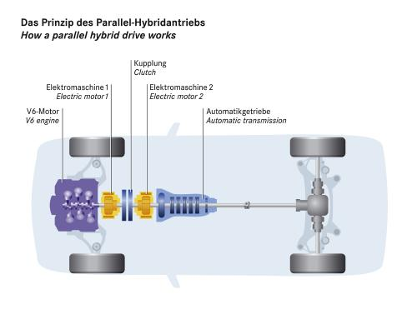 | S-Class Hybrid  The S-Class hybrid was presented at the autoshow in January 2004, and this time the hybrid drive with V6 gasoline engine (M112) had two electric motors, with 25 kW (34 hp) each, instead of one shown at the IAA in 1999.  A 28 module NiMH battery with 6 Ah, 200 Volts and 1.2 kWh was used. It weighs 99.3 lbs, was supplied by Varta and could supply 20 kW for 30 seconds.  pictures from the 2004 Detroit auto show

electric hybrid drive system (S-Class, NAIAS 2004)
Output | V6 engine  Electric motor 1  Electric motor 2 | 180 kW - 241 hp  25 kW - 34 hp  25 kW - 34 hp
Max. torque | V6 engine  Electric motor 1  Electric motor 2 | 350 Nm - 258 lb-ft  150 Nm - 111 lb-ft  300 Nm - 221 lb-ft

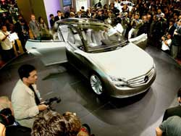 | Mercedes F500 and GST II Hybrids  A state-of-the-art diesel hybrid unit utilising a disc motor was presented in the F500 Mind research car in Tokyo in October 2003. It has a total power output of 234 kW, 250 hp from a 4.0 liter V8 CDI turbodiesel and 68 hp from a single electric motor integrated into the transmission/driveline and a Li-Ion battery. Due to the P2 hybrid configuration the torque of the internal combustion engine and of the electric motor are added in boost mode, 560 Nm plus 300 Nm yielding a total torque of 860 Nm. In the new European driving cycle the efficiency improves 20 per cent above standard CDI turbodiesel powered models. This engine system was also shown in the GST II prototype in Detroit in January 2004, and with four wheel drive like in the M-Class HYPER.  October 2003 and January 2004

M-Class HYPER diesel-electric hybrid
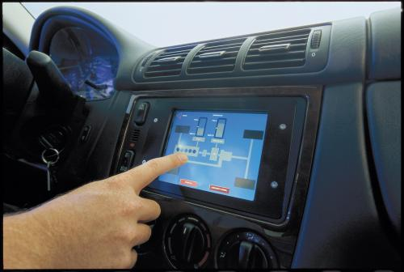 | A driver can constantly follow the driving modes on a small monitor next to the steering wheel. The display shows the interaction between the combustion engine and the electric motor, and between the energy storage devices and the electronic control units.
DaimlerChrysler Research has introduced the M-Class HYPER - a new hybrid vehicle that consumes up to 20 percent less fuel than a comparable production model. The powertrain of this sporty four-wheel drive vehicle is equipped with a special clutch and an electric motor that eliminate the need for a generator or starter. The result is not only a reduction in vehicle weight, but also reduced costs.
Stuttgart. December 1, 2003. The English word "hybrid" derives from the Latin "hybrida", which means "half-breed". In the automotive industry, engineers use the term hybrid vehicle to designate an automobile that has two energy converters - combustion engine and an electric motor, let's say. Because it has two power sources, such a vehicle also requires two energy stores - a fuel tank and a high-voltage battery. But if you took a peek under the hood of one of the latest hybrid vehicles developed by DaimlerChrysler Research — the M-Class HYPER — you would hardly believe that this sport-utility vehicle is a hybrid. Although the standard 2.7-liter CDI diesel engine would be impossible to overlook, you would notice that the M-Class HYPER doesn’t appear to be equipped with a conventional electric motor and the associated battery.
Head of Advanced Propulsion Systems, Prof. Karl E. Noreikat, holds the key to this mystery. “We have already achieved a high degree of integration of the two drive units,” he explains. “The electric motor is being ever-more tightly integrated into the powertrain and now takes up almost no additional space. It is positioned directly on the clutch shaft, between the clutch and the transmission, with which it forms a connected unit.”
From the cylinder to the disc
This integration was realized thanks to a new design for the electric motor. The motor doesn’t have the elongated, cylinder-shaped rotor found in conventional electric motors, such as those in drills, for example. Instead, the new type of electric motor features a very narrow, ring-shaped rotor with a comparatively large diameter. Noreikat and his team refer to the contrasting designs as the “sausage” and the “disc” motors.
With an output of 61 hp (45 kW), the high-torque disc motor has the advantage that it can be easily incorporated into existing drive trains. And its sophisticated electronic control system and state-of-the-art clutch offer even more benefits:
- The disc motor serves as both a starter and a generator, eliminating the need for these components. In addition to reducing vehicle weight, this also simplifies the entire powertrain and the wiring.
- There also is no need for the second electric motor found in the majority of hybrid vehicles already on the market. Such second motors increase the weight and costs of a vehicle, and they also take up a lot of space.
- And in contrast to hybrid concepts realized to date, the regenerative power — the electrical energy recovered from the vehicle’s kinetic energy per time unit — is twice as much as achieved by previous hybrid concepts. One result of this is that the M-Class HYPER consumes up to 20 percent less fuel than the comparable Mercedes-Benz ML 270 CDI production vehicle, according to the New European Driving Cycle.
Prof. Herbert Kohler, head of the Body and Powertrain research unit, can point to still another advantage. “Although they consume less fuel, all of our hybrid vehicles offer considerably better driving dynamics than comparable conventional vehicles,” Kohler reports. The reason is that electric motors immediately reach their maximum torque when a vehicle is started, which means that the car can accelerate very quickly from a standing start. The electric motor can also support the combustion engine with additional torque while a vehicle is being driven, which improves acceleration as well. As a result, the M-Class HYPER powered by a 163 hp (120-kW) five-cylinder in-line turbodiesel engine can match the acceleration of an M-Class equipped with a more powerful engine of the next highest rating.
New combinations of proven parts
Lower fuel consumption, fewer emissions, superior driving dynamics and easy integration into the powertrain — the advantages of the M-Class HYPER are the results of the work carried out by Noreikat’s team in their search for a simple and compact solution. “Our aim was to develop effective new combinations of proven parts that would allow us to come up with reliable, cost-effective solutions,” explains Noreikat.
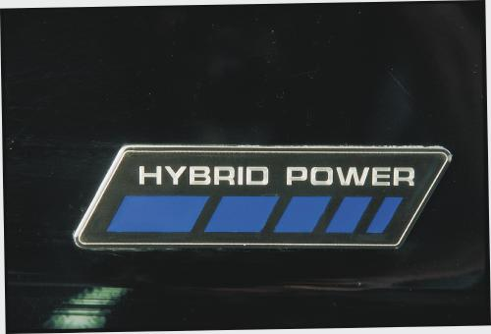
The engineers succeeded in making optimal use of the advantages of hybrid technology. Using a simple “parallel hybrid concept,” they retained all of the comfort-enhancing and performance features of a conventional drive train — and even improved them. “One advantage here was that we didn’t have to modify the transfer case of the permanent four-wheel drive in order to assemble the hybrid system,” reports Christof Bunz, a member of Noreikat’s team. Bunz and his colleagues made a considerable investment of time and effort in the development of the electronically controlled clutch unit, which controls the constantly changing interaction between the combustion engine, the electric motor and the automated 6-speed manual transmission. The clutch is remarkable because it can balance the different speeds and torques of the motor, the engine and the transmission so gently that the vehicle is guaranteed to run smoothly. And drivers will barely be aware of gear shifts during acceleration. A closer look at the different driving modes gives a clearer understanding of just how clever the clutch really is:
When starting up, driving at low speeds in city traffic or when stuck in a traffic jam, the diesel engine is switched off altogether; only the electric motor propels the vehicle. Depending on driving conditions, the clutch ensures that the combustion engine is push-started once the vehicle reaches approximately 25 km/h. In normal driving mode, the combustion engine powers the car. “Here, the electric motor is only used to synchronize the transmission during gear shifts,” says Bunz. During the acceleration process — while overtaking, for example — the electric motor is automatically activated, so that the torques of the motor and the engine are combined. This is what engineers call the “booster function.” During extended application of the vehicle’s brakes, the diesel engine switches off and the electric motor is used for regeneration. The motor is powered by the wheels via the transmission and functions as a generator, converting kinetic energy into electrical energy. This energy is then fed into the car’s battery. The battery is also charged when the vehicle is being driven at a constant highway cruising speed, and the combustion engine is not required to operate at its maximum output. In this mode it is the engine, not the transmission, that turns the motor so that it functions as a generator and charges the battery.
Water-cooled battery
The battery used in the hybrid vehicle is a water-cooled, nickel metal-hydride battery with an output of 50 kW. It is installed together with the electronic battery control in the spare wheel well at the rear of the vehicle. And in addition to being a space-saver, this arrangement also solves the mystery of that missing second energy-storage device. You remember. The one that was nowhere to be found under the hood.
December 1, 2003
©1998-2004 DaimlerChrysler. All rights reserved.
Continental's integrated starter alternator damper (ISAD) chosen by General Motors
for GM's hybrid truck project. At the time the prevalent thinking was that this project would signal the move towards 42Volt battery and electrical systems.
MIT/Industry Consortium on Advanced Automotive Electrical/Electronic Components and Systems
Jan 7, 2003
Maybach active integrated rectifier regulator
The active integrated rectifier regulator (AIRR) developed for the Maybach increases the efficiency of rectifing the AC current supplied by the generator to DC suitable for charging the battery and supplying the onboard circuits, and foreshadows the move to the integrated starter alternator over the next decade.
International Rectifier Announces Technology Breakthrough
Dec 18, 2002
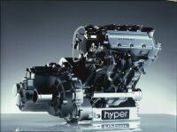
MCC smart GmbH: smart HYPER
On the IAA 2001 smart showed a CDI diesel electric hybrid developed together with Zytek. The consumption improved 13% over the already fuel efficient smart cdi and in the European driving cycle less than 3 liters per 100 kilometers were consumed, that's a fuel economy of better than 78 MPG in USA numbers.
Zytek Group
Mercedes A-Class Hyper
The A-Class diesel electric hybrid was based on a 1.7 liter direct injection turbodiesel with 66 kW in the front and a 26 kW electric booster in the rear. Acceleration improved to 8 seconds from 13 for the diesel alone while the fuel economy improved 20% to 4 liters per 100 kilometers (59 MPG). The prototype was green and not blue as shown in the graph above.
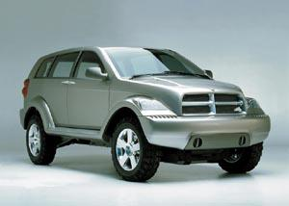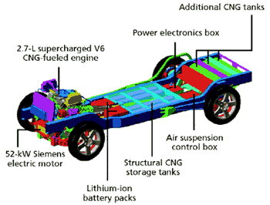
L.A. Autoshow 2001: Dodge Powerbox CNG hybrid concept
Dodge showed a CNG gas electric TTR hybrid. The supercharged 2.7 liter V6 with 250 hp (187 kW) running on compressed natural gas drives the rear wheels while a Siemens Automotive electric motor with 70 hp (52 kW) drives the front wheels. The two systems are not connected other than through the road. Compared to a Durango the PowerBox fuel economy improves to 25 MPG, or 60% and the range is 350 miles. Chrysler's head of engineering Richard Schaum: "Introducing a CNG-electric hybrid SUV, with patented 'through-the-road' (TTR) technology, gives consumers the option of an environmentally-friendly vehicle without sacrificing their wants and needs for both performance and utility." Lateron, on May 17, 2002, the Detroit News reported the Durango hybrid was discontinued due to low demand.
Siemens Automotive announces the Integrated Starter Generator (ISG)
"Siemens Integrated Starter Generator Stands Ready To Meet SUV Makers' Aggressive Fuel Economy Targets"
"Siemens Soft Hybrid Stands Ready to Meet SUV Makers' Aggressive Fuel Economy Targets"
Oct 16, 2000 and Mar 7, 2001
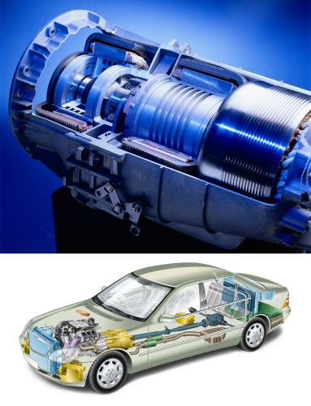 | Mercedes S-Class RWD Hybrid  An early Mercedes hybrid, the first RWD hybrid, was shown at the 1999 IAA in Frankfurt. A 132 kW/180 hp V6 gasoline engine is coupled to a planetary transfer case complete with dual-mass flywheel and 80 kW electric motor. Which of the drive systems is being used depends on the way the sedan is driven. A micro-computer always gives priority to the engine that offers most benefits in the particular situation. An intelligent combination of the two power plants is possible for example after a cold start when the gasoline engine operates in an optimal warm-running program with the electric drive offsetting any performance differences when driving off or accelerating. With the aid of this hybrid drive up to 22 per cent fuel may be saved in the European driving cycle. Exhaust emissions from the research vehicle are below the EU4 limits to be introduced in the year 2005.
Diesel-electric drive system in the Cito midibus debuts in 1998
In 1998 Mercedes-Benz introduced the Cito urban midibus. The innovative low-floor vehicle had a diesel-electric drive system. An OM 904 LA diesel engine with an output of 130 kW (177 hp) served to drive a generator. The generated electric power was fed into the electric traction motor. The unit consisting of diesel engine, generator and electric motor was installed in the rear of the vehicle and called a power pack. Mercedes-Benz developed the system together with Siemens. The Cito was built from 1999 to 2003. In 2000 it won the distinction of "Bus of the Year 2001."
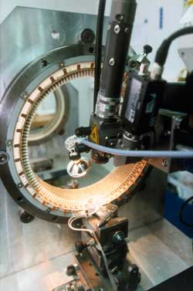 |   Integrated starter alternator damper (ISAD) wins the German Business Innovation Award 1997  Continental presents the integrated starter alternator and damper and receives the German Business Innovation Award in 1997. Lateron in 1998 Continental ISAD Electronics Systems GmbH & Co. KG in Kцln partners with Delco Remy to develop it further. The picture shows an ISAD inspection station for quality control, before series production begins.
Audi Duo A4 Avant diesel-electric plug-in hybrid and Toyota Prius debut in 1997
After showing concepts for several years starting around 1989, Audi introduced the Audi Duo A4 Avant at the IAA in 1997. It was based on the A4 wagon and had a 1.9 liter TDI direct injection turbodiesel and Siemens electric motor, both driving the front axle. 22 lead acid batteries in series with 10 kWh capacity weighed 320 kg and were charged primarily by plugging them into a regular 220 Volt outlet, and secondarily when driving. The duo was substantially more expensive than the regular diesel model. Only 60 were sold. Ten Audi Duos particiated in the ELCIDIS program to evaluate their performance over 30 months. 38% of the total milage covered in the test was in electric mode. The ELCIDIS report concluded the Audi Duo uses more energy than the Audi A4 1.9 TDI standard vehicle. In the following years the European car industry focussed on diesels instead. In the same year, 1997, Toyota introduced the Prius gas-electric hybrid at the Tokyo motor show for the domestic market in Japan, albeit with 1.7 kWh NiMH battery weighing 57 kg and without plug-in capability nor diesel engine.
European Commission: ELCIDIS Electric Vehicle City Distribution
Who'll Help Build Hayek's Dream? : Swatch for This Car
Nicolas Hayek has a vision for a hybrid SwatchMobile with a range of 550 miles. This article appeared on January 15, 1994 in the International Herald Tribune. In the concept Swatchmobile a small 2 cylinder 250 cc gasoline engine with 40 hp drives a generator (genset) and charges a battery, which in turn power four individual electric wheel mounted motors.
Mercedes-Benz C-class "Taxi Hybrid" in 1993
This was the first parallel hybrid from Mercedes-Benz. It combined a 55 kW/75 hp inline four diesel with an electric motor, with an output of 20 kW/28 hp and 130 Nm of torque, and 120 Volt battery. In electric mode it can travel about 15 miles. Two years later another C-Class model followed with serial hybrid engine.
Hybrid with boxer engine in 1982
Some guys at DaimlerBenz Research unveiled the first mobile prototype with hybrid technology in 1982. This vehicle, however, was fitted with only a two-cylinder horizontally opposed boxer engine, enough to keep the car on the road if the battery ran flat.
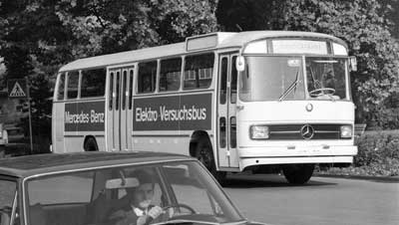
Mercedes introduced world's first hybrid bus in 1969
At the IAA in 1969 Mercedes-Benz presented a technological feat: the Elektro-Versuchsbus, an electric hybrid bus for testing, designated the OE302 ("E" standing for Electric) with 205 hp electric motors, plenty for a bus at the time, 380 Volt Varta lead acid batteries and 65 hp diesel engine, in a series hybrid configuration. It had a range of 55 kilometers on electricity alone and could run all day in service when also using the diesel. The top speed was around 70 km/h.
Ferdinand Porsche's hybrid
The Lohner Porsche Mixte in 1902 had a Daimler four cylinder gas engine with generator to charge a lead acid battery and supply electric wheel hub motors, one in each wheel.

